Find a variant of loading a car with a nominal capacity

tons of three types of cargo, which provides the maximum profit from

their transportation. The weight of cargoes accordingly makes 1 t, 2 t, 3 t. Profit from

the transport of xk units of the k-th cargo is given by the function

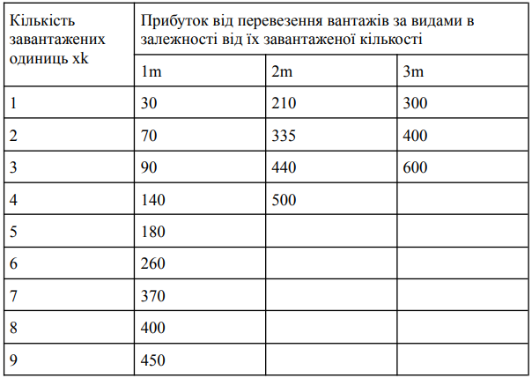

**Input**:

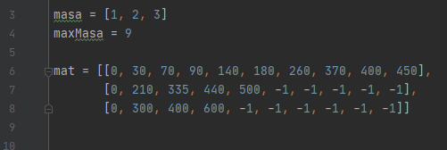

**Result:**

